Cognizant - DN 4.0 Deep Skilling Java FSE

Week 05 - Microservices with Spring Boot 3 and Spring Cloud

Superset ID: 6383725

Name: G Ashritha

**Exercise 1: Creating Microservices for account and loan**

//AccountController.java

package com.cognizant.account.controller;

import org.springframework.web.bind.annotation.*;

import java.util.Map;

@RestController

@RequestMapping("/accounts")

public class AccountController {

@GetMapping("/{number}")

public Map<String, Object> getAccountDetails(@PathVariable String number) {

return Map.of(

"number", number,

"type", "savings",

"balance", 234343 );

}}

**Output:**

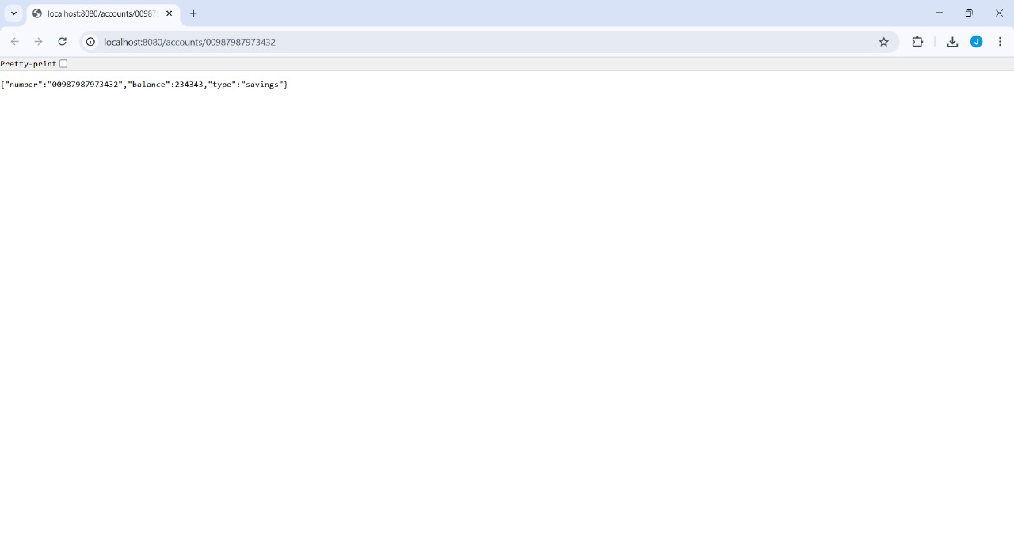

//LoanController.java

package com.cognizant.loan.controller;

import org.springframework.web.bind.annotation.*;

import java.util.Map;

@RestController

@RequestMapping("/loans")

public class LoanController {

@GetMapping("/{number}")

public Map<String, Object> getLoanDetails(@PathVariable String number) {

return Map.of(

"number", number,

"type", "car",

"loan", 400000,

"email", 3258,

"tenure", 18

);

}

}

**Output:**

